## Merchant

Demo date: Oct 11 th  
Scoping start date: October 15th

MSA Signature Date: October 17th  
Onboarding Kick Off Date: October 28th

[If Exists] Opt Out Date: n/a  
Go Live Date:

GTM POC: Jarrett  
Implementation POC: Ariel Royce

ERP: QBO

Tax Integration: Other

### 

### Key people at Merchant

### CEO: [Trevor Pare](https://www.linkedin.com/in/trevor-pare/)

### 

| Notes Sections [Ops International Team to Ignore] *(AE/ Implementation to fill)*   * Info on how merchant bills   + Today, when someone wants to buy he just sets up a stripe subscription. Monthly flat. Soon to add variables * Is there any important merchant relationship information?  1) What is the merchant temperament? Very very cool 2) Is there a key POC: (i.e.: who is the buyer/decision maker?) CEO- Trevor 3) What are the Tabs features that the key POC cares about? Variable billing, ACH |
| --- |

### Company Summary *(AE to fill)*

Design subscription of CPG Brands

Goals (North star)  
*(AE/ Implementation to fill)*

They were spending $9K per billing cycle on Stripe fees. Stripe is great for SaaS, but wont work as they add services and rely on more ACH with rising ACV's.

### Billing model *(AE/ Implementation to fill)*

* Are there unique things about the customer creation process for this merchant?
  + No contracts, only a spreadsheet of customer info
* Information on how merchant bills
  + Today is using stripe
* How contract is broken up
  + N/A
* One-off things to know about the merchant
  + Has a Canadian and US account. Wants money to flow into each account based on billing location:

### Contract Processing Steps *(Implementation/Success to fill)*

Contract Template Questions:

* Start date is 2 different dates
* 3 months + quarterly billing is a little confusing
  + Billed at the beginning of each term?

**Contracts**

**Print Orders**

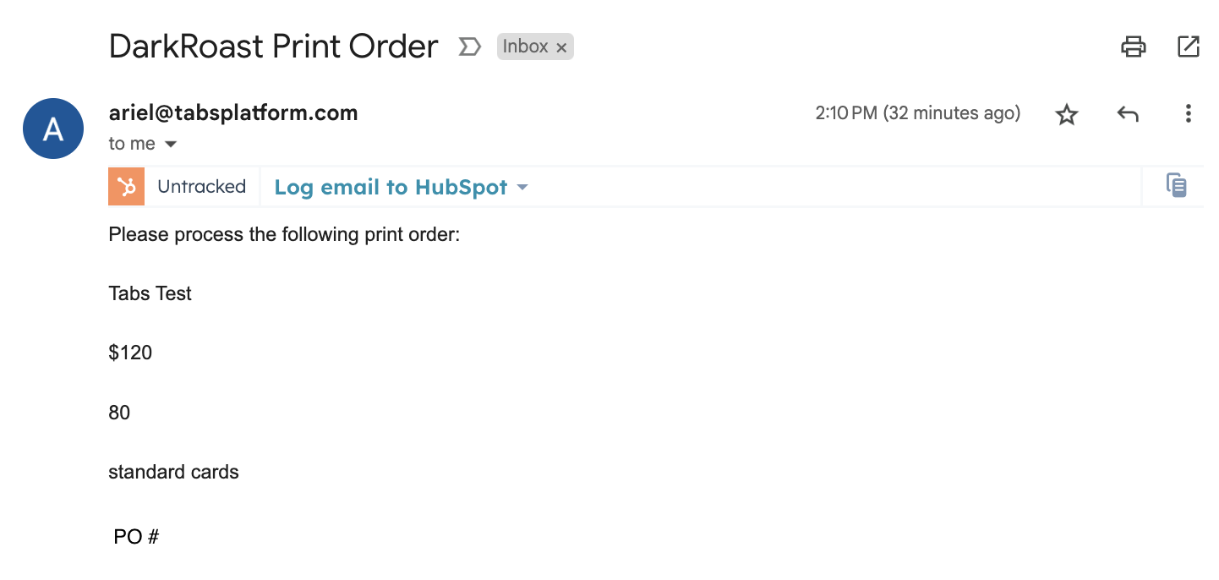

1. Steps to process
2. Anything to ignore in contracts?
3. Specifics processing things the merchant has requested that may differ by contract (e.g. always back-date invoice date to final day of the month)
4. Default Service Term
   1. If None Listed, Ops Default is 1 Year
5. Default Net Payment Terms
   1. If None, Ops Default is 0
6. Default Billing Frequency
   1. If None Listed, Ops Default is Monthly
7. How do we handle taxes as a line item?
   1. If None Listed, Ops Default is every tax line item becomes a BT

### Events Processing (if necessary) *(Implementation/Success to fill)*

* Any important information on events billing

Integration Items Processing (if necessary)  
*(Implementation/Success to fill)*

* What are the instructions for assigning integration items?
* Example: All Statsig integrations items should be labeled as “Sales”
* Example: All “Pinata” integration items should be labeled as “Software Subscription Bundle” unless otherwise noted by Merchant

Post Processing Communications (if necessary)  
*(Implementation/Success to fill)*

* Does the Ops Team need to notify anyone on the team re: completion of processing batches in Implementation or Active phase?
* Who needs to be notified and when?
  + Example:
    - Who: Customer Success [Azmat Aziz] needs to be notified
    - Where: Messari internal merchant channel
    - When: contracts are processed [Merchant Phase: Active]

### Customer Information *(Implementation/Success to fill)*

* Any important information on specifics customers of this merchant
  + Special memo’s certain invoices require
  + Invoice changes due to merchant/customer relationship

### Feature Requests *(AE/Implementation/Success to fill)*

* FR 1
  + What is it
  + Why it's important
  + Urgency

### Rewatch Calls *(AE/Implementation/Success to fill)*

* <https://tabs.rewatch.com/video/a0lxsb2esqvflv8e-trevor-jarrett-meeting-october-11-2024>
* <https://tabs.rewatch.com/video/t340da1q1s9ejqyp-tabs-dark-roast-follow-up-october-15-2024>